City of Wanneroo

Home
2021 CENSUS
UPDATE
The 2021 Census provides an opportunity to rebase our forecasts with up-to-date and reliable data.
We are currently updating all forecast.id sites. If the timestamp below any chart or map states "November 2022", "December 2022", "January 2023" or "February 2023" this website has been updated with 2021 Census information.
Sign up to the forecast.id newsletter for regular updates.
The City of Wanneroo population and household forecasts present what is driving population change in the community and how the population and age structure will change each year between 2021 and 2046.
The forecasts are designed to provide community groups, Council, investors, business, students and the general public with knowledge to make confident decisions about the future.
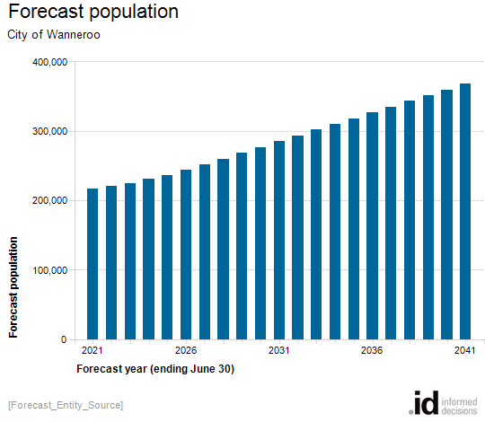
[UpdateFooter]

